Q1.

SELECT LD.LOCATION_NAME,

TD.TIME_YEAR CONTRACT_YEAR,

TD.TIME_MONTH CONTRACT_MONTH,

SUM(JF.QUANTITY_ORDERED)* SUM(JF.UNIT_PRICE) JOB_AMOUNT_ORDERED,

ROUND(CUME_DIST() OVER (PARTITION BY LD.LOCATION_NAME, TD.TIME_YEAR ORDER BY TD.TIME_MONTH,SUM(JF.QUANTITY_ORDERED)* SUM(JF.UNIT_PRICE)),2) AS CUMM_JOB_AMOUNT_ORDERED

FROM W_JOB_F JF,

W_LOCATION_D LD,

W_TIME_D TD

WHERE JF.LOCATION_ID = LD.LOCATION_ID

AND JF.CONTRACT_DATE = TD.TIME_ID

GROUP BY LD.LOCATION_NAME,

TD.TIME_YEAR ,

TD.TIME_MONTH

ORDER BY LOCATION_NAME,

CONTRACT_YEAR,

CONTRACT_MONTH;

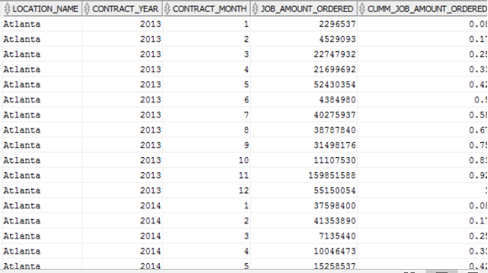

Q2.

SELECT LD.LOCATION_NAME,

TD.TIME_YEAR CONTRACT_YEAR,

TD.TIME_MONTH CONTRACT_MONTH,

SUM(JF.QUANTITY_ORDERED) * SUM(JF.UNIT_PRICE) JOB_AMOUNT_ORDERED,

ROUND(AVG(SUM(JF.QUANTITY_ORDERED)* SUM(JF.UNIT_PRICE)) OVER (PARTITION BY LD.LOCATION_NAME ORDER BY TD.TIME_YEAR, TD.TIME_MONTH ROWS 11 PRECEDING),2) AS MOVING_AVG_JOB_AMOUNT_ORDERED

FROM W_JOB_F JF,

W_LOCATION_D LD,

W_TIME_D TD

WHERE JF.LOCATION_ID = LD.LOCATION_ID

AND JF.CONTRACT_DATE = TD.TIME_ID

GROUP BY LD.LOCATION_NAME,

TD.TIME_YEAR ,

TD.TIME_MONTH

ORDER BY LOCATION_NAME,

CONTRACT_YEAR,

CONTRACT_MONTH;

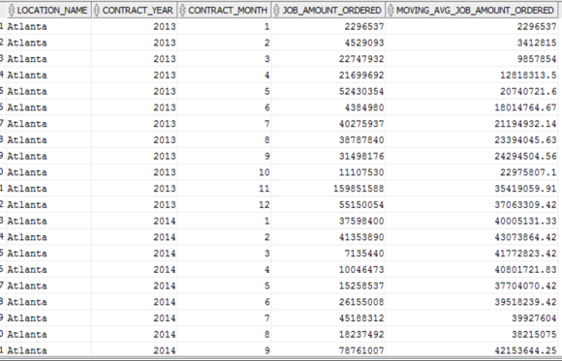

Q3.

SELECT INS.LOCATION_NAME ,

INS.CONTRACT_YEAR ,

INS.CONTRACT_MONTH ,

SUM(INS.INVOICE_AMOUNT) - SUM(CS.COST_TOTAL) AS PROFIT ,

RANK() OVER (PARTITION BY INS.CONTRACT_YEAR ORDER BY (SUM(INS.INVOICE_AMOUNT) - SUM(CS.COST_TOTAL))DESC) ANNUAL_RANK

FROM VW_INVOICEREVENUESUMMARY INS,

VW_SUBJOBCOSTSUMMARY CS

WHERE INS.JOB_ID = CS.JOB_ID

GROUP BY INS.LOCATION_NAME ,

INS.CONTRACT_YEAR ,

INS.CONTRACT_MONTH

ORDER BY INS.CONTRACT_YEAR,

ANNUAL_RANK ;

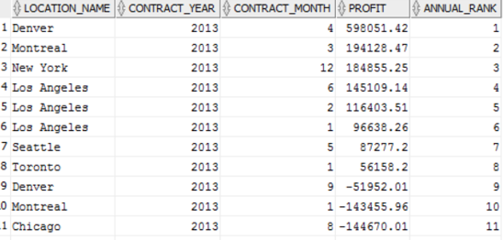

Q4.

SELECT INS.LOCATION_NAME ,

INS.CONTRACT_YEAR ,

INS.CONTRACT_MONTH ,

CASE

WHEN SUM(INS.INVOICE_AMOUNT)>0

THEN ROUND((SUM(INS.INVOICE_AMOUNT) - SUM(CS.COST_TOTAL))/SUM(INS.INVOICE_AMOUNT),2)

ELSE 0

END AS PROFIT_MARGIN ,

RANK() OVER (PARTITION BY INS.CONTRACT_YEAR ORDER BY

CASE

WHEN SUM(INS.INVOICE_AMOUNT)>0

THEN ROUND((SUM(INS.INVOICE_AMOUNT) - SUM(CS.COST_TOTAL))/SUM(INS.INVOICE_AMOUNT),2)

ELSE 0

END DESC) ANNUAL_RANK

FROM VW_INVOICEREVENUESUMMARY INS,

VW_SUBJOBCOSTSUMMARY CS

WHERE INS.JOB_ID = CS.JOB_ID

GROUP BY INS.LOCATION_NAME ,

INS.CONTRACT_YEAR ,

INS.CONTRACT_MONTH

ORDER BY INS.CONTRACT_YEAR,

ANNUAL_RANK ;

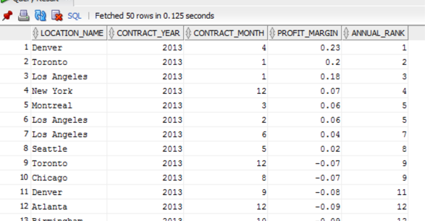

Q5.

SELECT INS.JOB_ID,

INS.LOCATION_NAME ,

INS.CONTRACT_YEAR ,

INS.CONTRACT_MONTH ,

CASE

WHEN SUM(INS.INVOICE_AMOUNT)>0

THEN ROUND((SUM(INS.INVOICE_AMOUNT) - SUM(CS.COST_TOTAL))/SUM(INS.INVOICE_AMOUNT),2)

ELSE 0

END AS PROFIT_MARGIN ,

PERCENT_RANK() OVER (ORDER BY

CASE

WHEN SUM(INS.INVOICE_AMOUNT)>0

THEN ROUND((SUM(INS.INVOICE_AMOUNT) - SUM(CS.COST_TOTAL))/SUM(INS.INVOICE_AMOUNT),2)

ELSE 0

END) JOBS_PERCENT_RANK

FROM VW_INVOICEREVENUESUMMARY INS,

VW_SUBJOBCOSTSUMMARY CS

WHERE INS.JOB_ID = CS.JOB_ID

GROUP BY INS.JOB_ID,

INS.LOCATION_NAME ,

INS.CONTRACT_YEAR ,

INS.CONTRACT_MONTH

ORDER BY JOBS_PERCENT_RANK DESC;

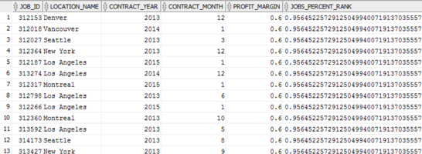

SELECT JOB_ID,

LOCATION_NAME ,

CONTRACT_YEAR ,

CONTRACT_MONTH ,

PROFIT_MARGIN ,

JOBS_PERCENT_RANK

FROM

(SELECT INS.JOB_ID,

INS.LOCATION_NAME ,

INS.CONTRACT_YEAR ,

INS.CONTRACT_MONTH ,

CASE

WHEN SUM(INS.INVOICE_AMOUNT)>0

THEN ROUND((SUM(INS.INVOICE_AMOUNT) - SUM(CS.COST_TOTAL))/SUM(INS.INVOICE_AMOUNT),2)

ELSE 0

END AS PROFIT_MARGIN ,

PERCENT_RANK() OVER (ORDER BY

CASE

WHEN SUM(INS.INVOICE_AMOUNT)>0

THEN ROUND((SUM(INS.INVOICE_AMOUNT) - SUM(CS.COST_TOTAL))/SUM(INS.INVOICE_AMOUNT),2)

ELSE 0

END) JOBS_PERCENT_RANK

FROM VW_INVOICEREVENUESUMMARY INS,

VW_SUBJOBCOSTSUMMARY CS

WHERE INS.JOB_ID = CS.JOB_ID

GROUP BY INS.JOB_ID,

INS.LOCATION_NAME ,

INS.CONTRACT_YEAR ,

INS.CONTRACT_MONTH

) Profit_Percent_Rank

WHERE JOBS_PERCENT_RANK >= 0.95;

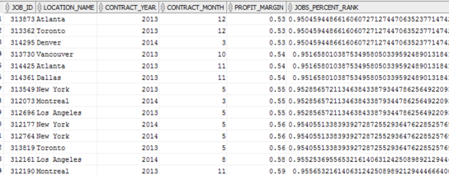

Q7.

SELECT SCD.SALES_CLASS_DESC,

TD.TIME_YEAR INVOICE_SENT_YEAR,

SUM(INF.QUANTITY_SHIPPED) - SUM(INF.INVOICE_QUANTITY) RETURN_QUANTITY,

RANK() OVER(PARTITION BY TD.TIME_YEAR ORDER BY (SUM(INF.QUANTITY_SHIPPED) - SUM(INF.INVOICE_QUANTITY)) DESC) ANNUAL_RANK

FROM W_JOB_F JF,

W_LOCATION_D LD,

W_INVOICELINE_F INF,

W_JOB_SHIPMENT_F JSF,

W_SUB_JOB_F SJF,

W_TIME_D TD,

W_SALES_CLASS_D SCD

WHERE JF.LOCATION_ID = LD.LOCATION_ID

AND JF.JOB_ID = SJF.JOB_ID

AND SJF.SUB_JOB_ID = JSF.SUB_JOB_ID

AND JSF.INVOICE_ID = INF.INVOICE_ID

AND INF.INVOICE_SENT_DATE = TD.TIME_ID

AND JF.SALES_CLASS_ID = SCD.SALES_CLASS_ID

GROUP BY SCD.SALES_CLASS_DESC,

TD.TIME_YEAR

ORDER BY INVOICE_SENT_YEAR,

ANNUAL_RANK;

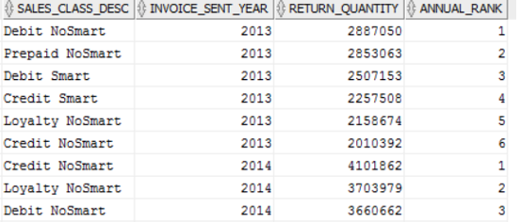

Q8.

SELECT SCD.SALES_CLASS_DESC,

TD.TIME_YEAR INVOICE_SENT_YEAR,

SUM(INF.QUANTITY_SHIPPED) - SUM(INF.INVOICE_QUANTITY) RETURN_QUANTITY,

RATIO_TO_REPORT(SUM(INF.QUANTITY_SHIPPED) - SUM(INF.INVOICE_QUANTITY)) OVER(PARTITION BY TD.TIME_YEAR) RETURNQTY_RATIO

FROM W_JOB_F JF,

W_LOCATION_D LD,

W_INVOICELINE_F INF,

W_JOB_SHIPMENT_F JSF,

W_SUB_JOB_F SJF,

W_TIME_D TD,

W_SALES_CLASS_D SCD

WHERE JF.LOCATION_ID = LD.LOCATION_ID

AND JF.JOB_ID = SJF.JOB_ID

AND SJF.SUB_JOB_ID = JSF.SUB_JOB_ID

AND JSF.INVOICE_ID = INF.INVOICE_ID

AND INF.INVOICE_SENT_DATE = TD.TIME_ID

AND JF.SALES_CLASS_ID = SCD.SALES_CLASS_ID

GROUP BY SCD.SALES_CLASS_DESC,

TD.TIME_YEAR

ORDER BY INVOICE_SENT_YEAR,

RETURNQTY_RATIO;

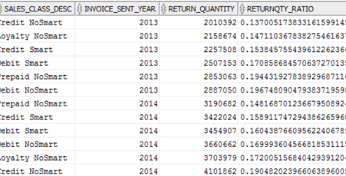

Q9.

SELECT SDS.LOCATION_NAME,

TD.TIME_YEAR YEAR_PROMISED,

SUM(SDS.BUSINESS_DAYS_DIFF) BUSINESS_DAYS_DIFF,

RANK() OVER(PARTITION BY TD.TIME_YEAR ORDER BY SUM(SDS.BUSINESS_DAYS_DIFF) DESC) RANK_DAYS_DELAYED,

DENSE_RANK() OVER(PARTITION BY TD.TIME_YEAR ORDER BY SUM(SDS.BUSINESS_DAYS_DIFF) DESC) DENSERANK_DAYS_DELAYED

FROM VW_SHIPPEDDATESTATS SDS,

W_TIME_D TD

WHERE SDS.DATE_SHIP_BY = TD.TIME_ID

GROUP BY SDS.LOCATION_NAME,

TD.TIME_YEAR;

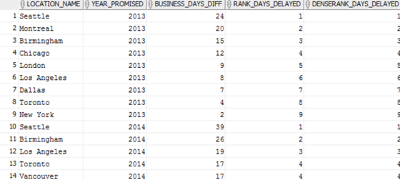

Q10.

SELECT SDS.LOCATION_NAME,

TD.TIME_YEAR YEAR_PROMISED,

COUNT(DISTINCT JOB_ID) JOBS_DELAYED_COUNT,

SUM(SDS.BUSINESS_DAYS_DIFF) BUSINESS_DAYS_DIFF,

CASE

WHEN SUM(QUANTITY_ORDERED)>0

THEN (SUM(QUANTITY_ORDERED)-SUM(SHIPPED_QTY_DELAYED))/SUM(QUANTITY_ORDERED)

ELSE 0

END AS DELAY_RATE,

RANK() OVER(PARTITION BY TD.TIME_YEAR ORDER BY

CASE

WHEN SUM(QUANTITY_ORDERED)>0

THEN (SUM(QUANTITY_ORDERED)-SUM(SHIPPED_QTY_DELAYED))/SUM(QUANTITY_ORDERED)

ELSE 0

END DESC) RANK_DAYS_DELAYED

FROM VW_SHIPMENTDELAYS_DATEPROMISED SDS,

W_TIME_D TD

WHERE SDS.DATE_PROMISED = TD.TIME_ID

GROUP BY SDS.LOCATION_NAME,

TD.TIME_YEAR;

